ABC’s Inventory Management System

Manage Staff (Delete Staff) Test Scripts

Table of Contents

DST001- Delete staff when staff is already displayed 3

Set 1 3

Result Screenshots: 3

DST002- Click ‘No’ when system prompts to confirm deletion of staff 5

Set 1 5

Result Screenshots: 5

DST003- Delete staff after searching for a staff 6

Data Set 1 7

Result Screenshots: 7

Data Set 2 9

Result Screenshots: 9

DST004- Click on ‘No’ when deleting staff after searching for a staff 11

Data Set 1 11

Result Screenshots: 11

# DST001- Delete staff when staff is already displayed

|  |  |  |  |  |  |
| --- | --- | --- | --- | --- | --- |
| **Test Name** | | Test delete staff when staff is already displayed (Test DST001) | | | |
| **Use Case Tested** | | Manage Staff | | | |
| **Test Description** | | This test tests if the system can delete a staff that is already displayed when the ‘Manage Staff’ page is opened. | | | |
| **Pre-Conditions** | | Users need be logged in as a Warehouse Staff (Warehouse Staff Access) in the Manage Staff page | | | |
| **Post-Conditions** | | A staff is deleted | | | |
| **Result (Pass/Fail/Warning/ Incomplete)** | | Pass | | | |
|  | **Test Step** | | **Expected Test Results** | **P** | **F** |
| 1. | Click on ‘Delete Staff’ icon at ‘Manage Staff’ | | System displays a dialog box to confirm if the user wants to delete the staff. | P |  |
| 2. | Click on ‘Yes’ | | System deletes the staff from the database. | P |  |
| 3. |  | | System displays an appropriate message. | P |  |

## Set 1

This test does not require any data.

### Result Screenshots:

**Step 1**

After clicking on ‘Delete Staff’ Icon at ‘Manage Staff’ system displays a dialog box to confirm if user wants to delete the staff

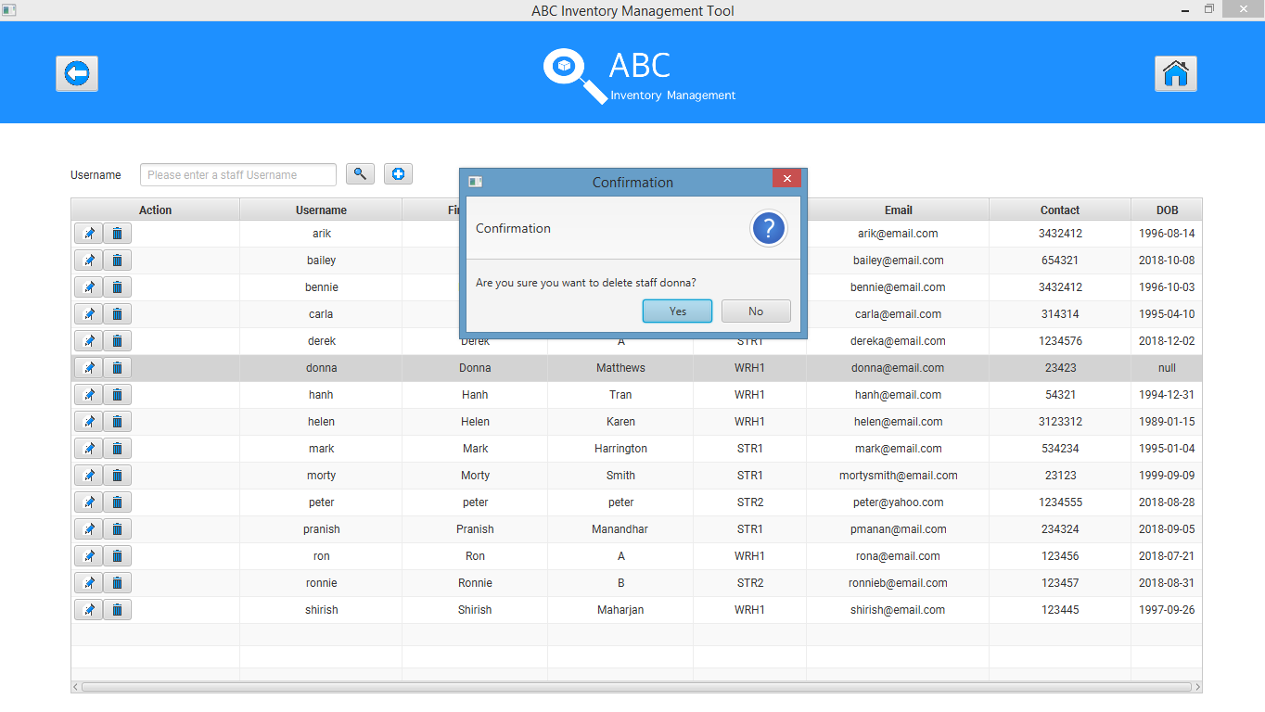

**Step 2**

User clicks on ‘Yes’ to confirm deletion of the staff

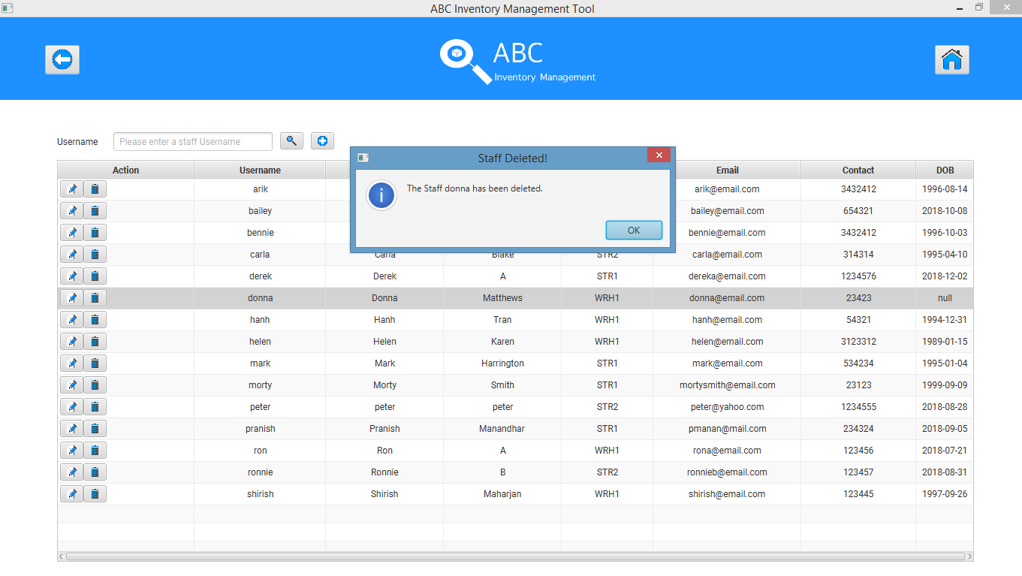

# DST002- Click ‘No’ when system prompts to confirm deletion of staff

|  |  |  |  |  |  |
| --- | --- | --- | --- | --- | --- |
| **Test Name** | | Test click ‘No’ when system prompts to confirm deletion of staff (Test DST002) | | | |
| **Use Case Tested** | | Manage Staff | | | |
| **Test Description** | | This test checks how the system reacts when user clicks on ‘No’ when system prompts to confirm deletion of staff. | | | |
| **Pre-Conditions** | | Users need be logged in as a Warehouse Staff (Warehouse Staff Access) in the Manage Staff page | | | |
| **Post-Conditions** | | ‘Manage Staff’ is displayed | | | |
| **Result (Pass/Fail/Warning/ Incomplete)** | | Pass | | | |
|  | **Test Step** | | **Expected Test Results** | **P** | **F** |
| 1. | Click on ‘Delete Staff’ icon at ‘Manage Staff’ | | System displays a dialog box to confirm if the user wants to delete the staff. | P |  |
| 2. | Click on ‘No’ | | System displays the ‘Manage Staff’ page and staff is not deleted. | P |  |

## Set 1

This test does not require any data.

### Result Screenshots:

**Step 1**

After clicking on ‘Delete Staff’ Icon at ‘Manage Staff’ system displays a dialog box to confirm if user wants to delete the staff

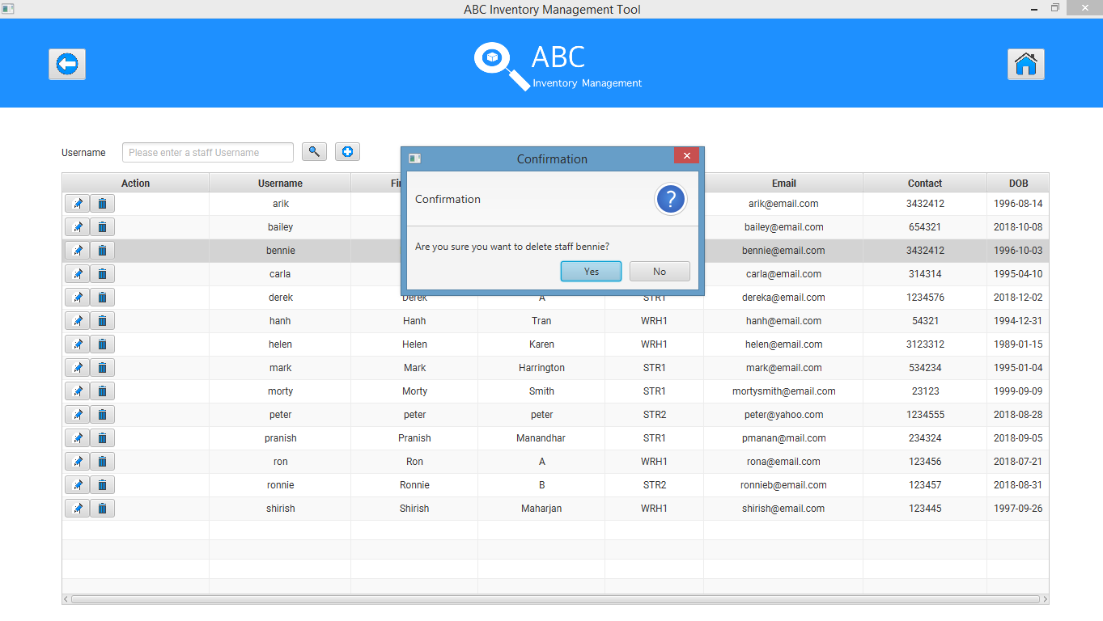

**Step 2**

System displays the ‘Manage Staff’ page after user clicks on ‘No’

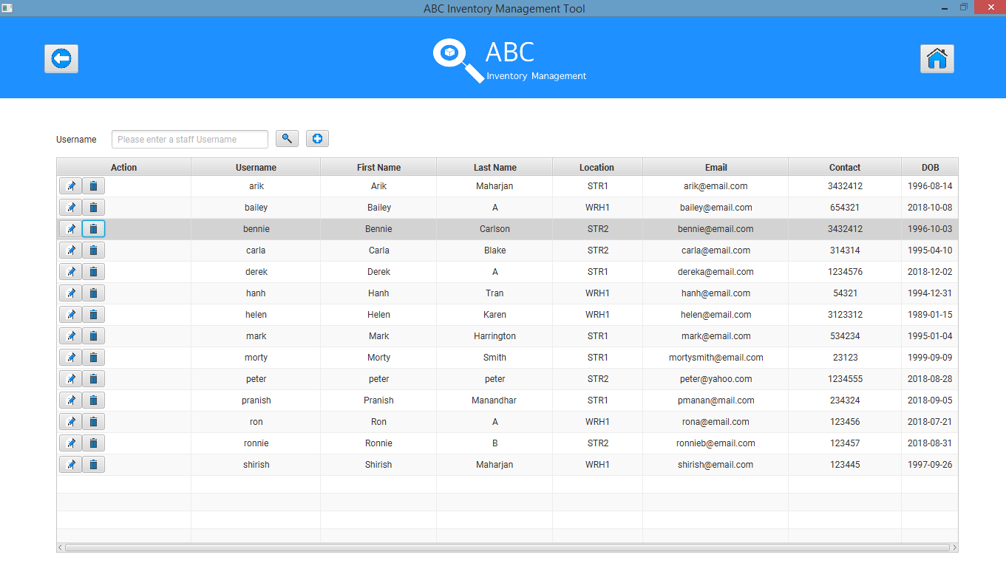

# DST003- Delete staff after searching for a staff

|  |  |  |  |  |  |
| --- | --- | --- | --- | --- | --- |
| **Test Name** | | Test delete staff after searching for a staff (Test DST003) | | | |
| **Use Case Tested** | | Manage Staff | | | |
| **Test Description** | | This test tests if the system can delete a staff after the staff is searched | | | |
| **Pre-Conditions** | | Users need be logged in as a Warehouse Staff (Warehouse Staff Access) in the Manage Staff page.  Staff must be searched. | | | |
| **Post-Conditions** | | Staff is deleted | | | |
| **Result (Pass/Fail/Warning/ Incomplete)** | | Pass | | | |
|  | **Test Step** | | **Expected Test Results** | **P** | **F** |
| 1. | Search for a staff to be deleted and click on the ‘Delete’ icon. | | System displays a dialog box to confirm if the user wants to delete the staff. | P |  |
| 2. | Click on ‘Yes’ | | System deletes the staff from the database. | P |  |
| 3. |  | | System displays an appropriate message. | P |  |

## Data Set 1

|  |  |
| --- | --- |
| **Data Set 1** | |
| **Field** | **Values** |
| **Username** | ron |

### Result Screenshots:

**Step 1**

User searches for the staff they wish to delete.

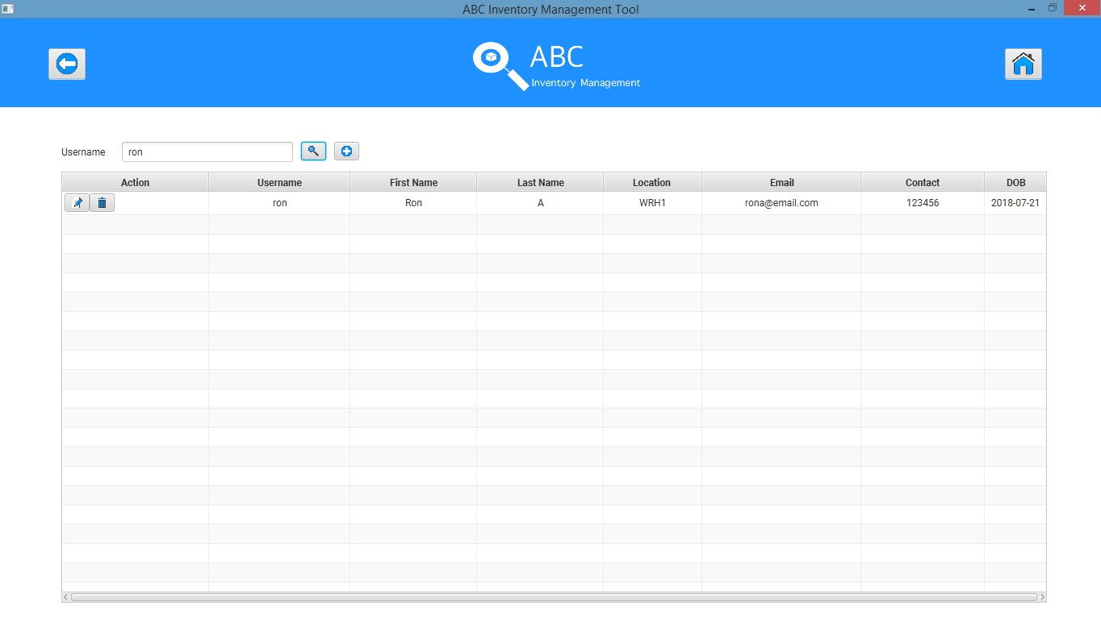

**Step 2**

System displays the confirmation dialog and the user enters ‘Yes’ button.

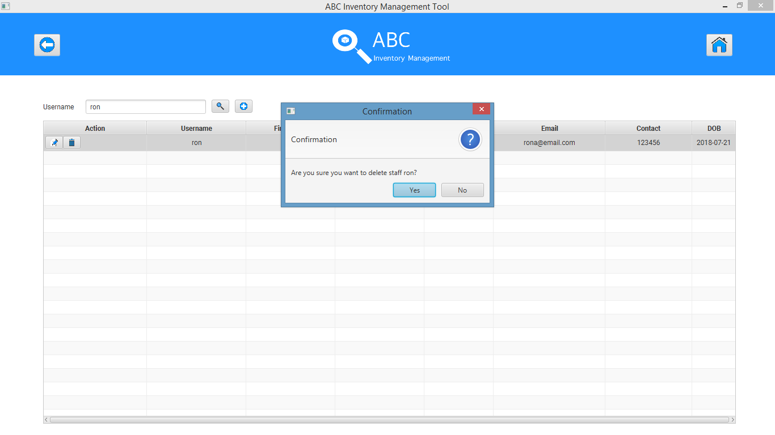

**Step 3**

System deletes the staff and displays an appropriate message.

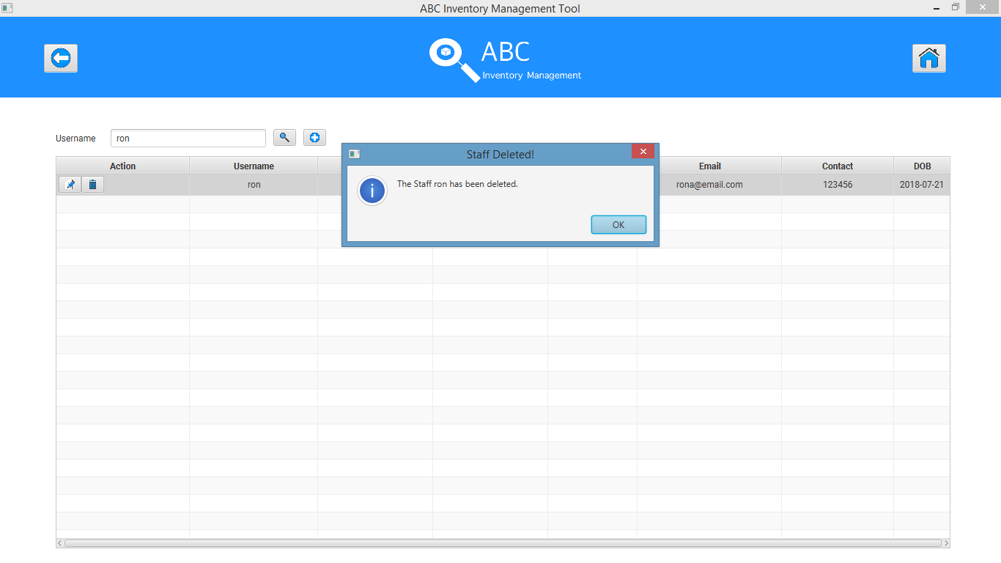

## Data Set 2

|  |  |
| --- | --- |
| **Data Set 2** | |
| **Field** | **Values** |
| **Last Name** | Manandhar |

### Result Screenshots:

**Step 1**

User searches for the staff they wish to delete.

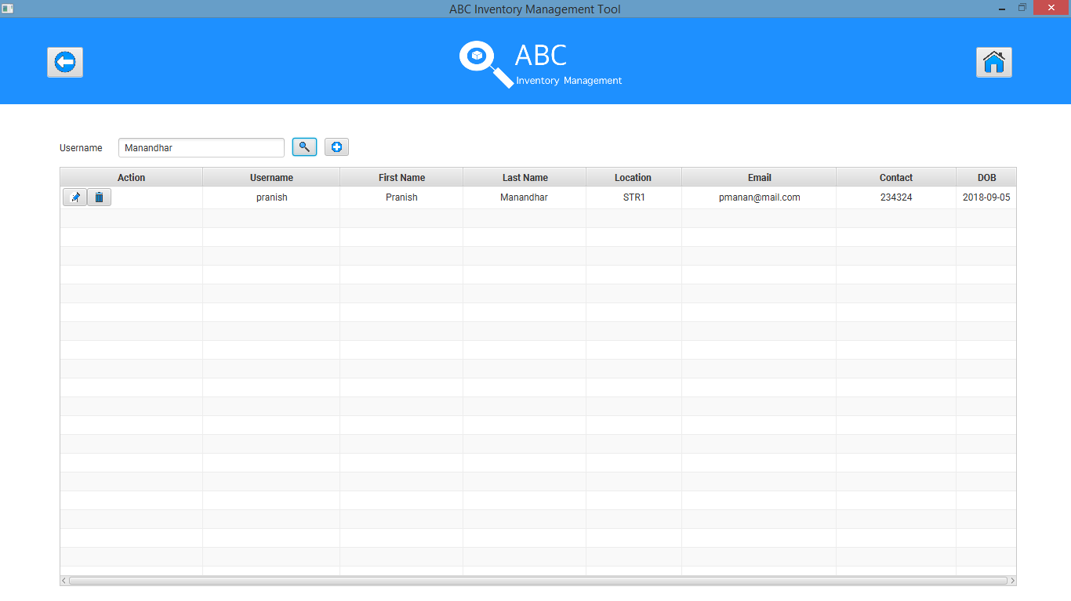

**Step 2**

System displays the confirmation dialog and the user enters ‘Yes’ button.

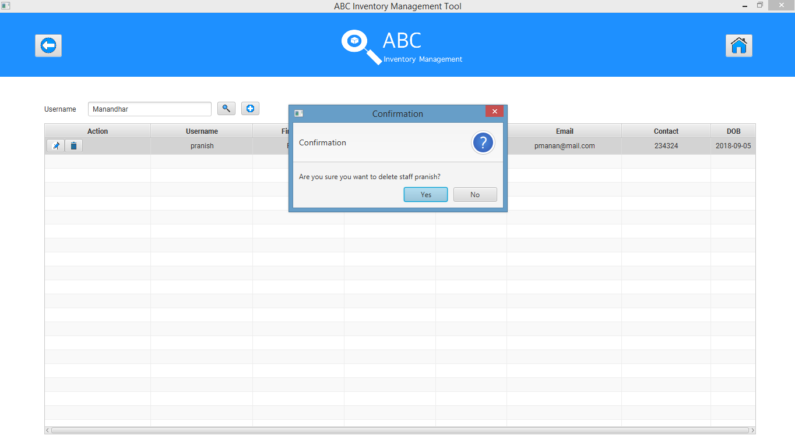

**Step 3**

System deletes the staff and displays an appropriate message.

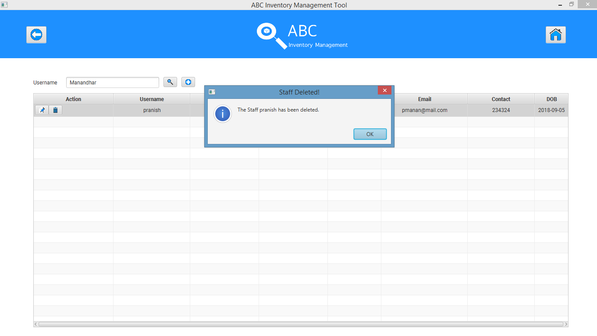

# DST004- Click on ‘No’ when deleting staff after searching for a staff

|  |  |  |  |  |  |
| --- | --- | --- | --- | --- | --- |
| **Test Name** | | Test Click on ‘No’ when deleting staff after searching for a staff (Test DST004) | | | |
| **Use Case Tested** | | Manage Staff | | | |
| **Test Description** | | This test tests how the system reacts when the user clicks on ‘No’ when searching for a staff and clicking on the ‘Delete’ icon. | | | |
| **Pre-Conditions** | | Users need be logged in as a Warehouse Staff (Warehouse Staff Access) in the Manage Staff page.  Staff must be searched. | | | |
| **Post-Conditions** | | Staff is not deleted. | | | |
| **Result (Pass/Fail/Warning/ Incomplete)** | | Pass | | | |
|  | **Test Step** | | **Expected Test Results** | **P** | **F** |
| 1. | Search for a staff to be deleted and click on the ‘Delete’ icon. | | System displays a dialog box to confirm if the user wants to delete the staff. | P |  |
| 2. | Click on ‘No’ | | Staff is not deleted. | P |  |

## Data Set 1

|  |  |
| --- | --- |
| **Data Set 1** | |
| **Field** | **Values** |
| **First Name** | Bennie |

### Result Screenshots:

**Step 1**

User searches for the staff they wish to delete.

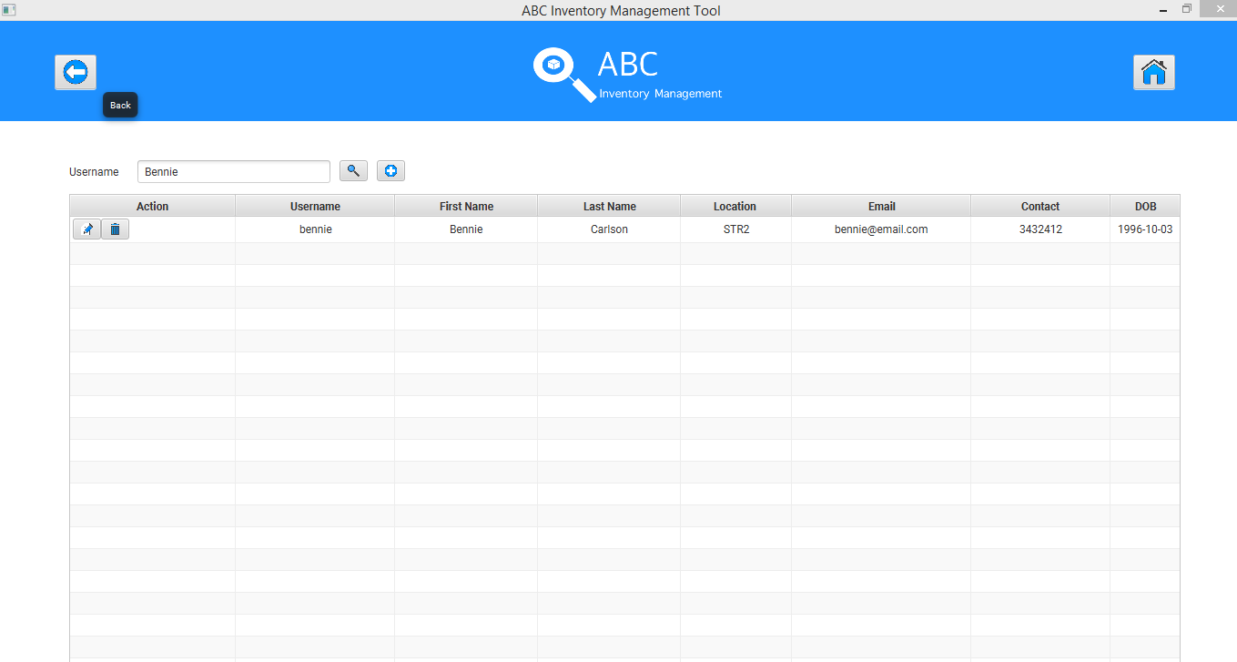

**Step 2**

System displays the confirmation dialog and the user enters ‘No’ button.

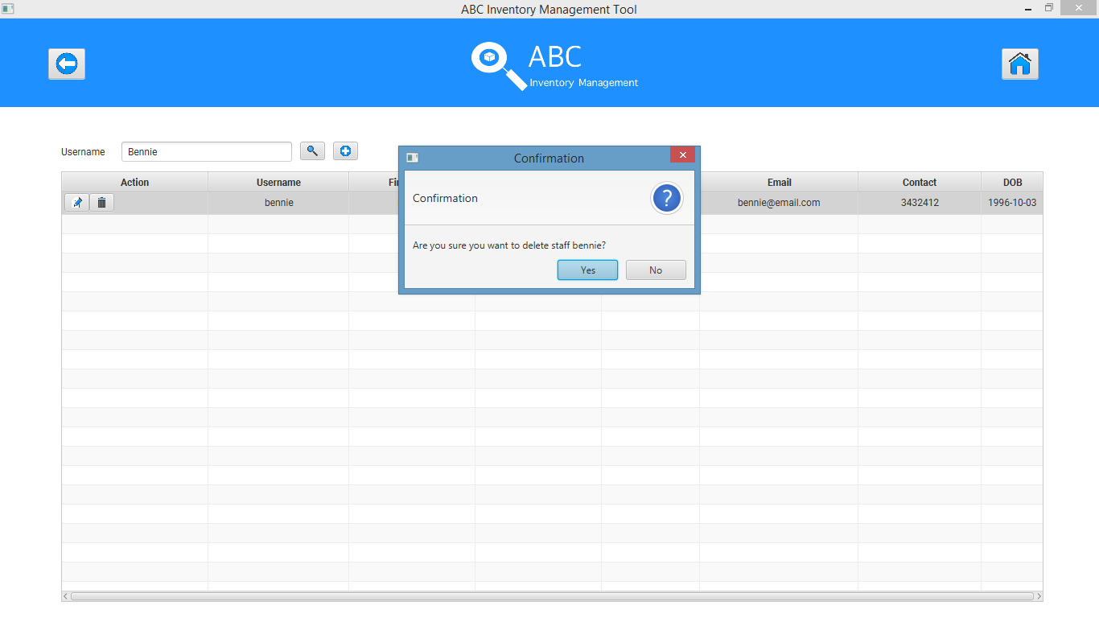

**Step 3**

System does not delete the staff

